**Data Analysis using Rapid miner studio.**

**Load Data:**

At first, I imported the dataset into rapid miner.

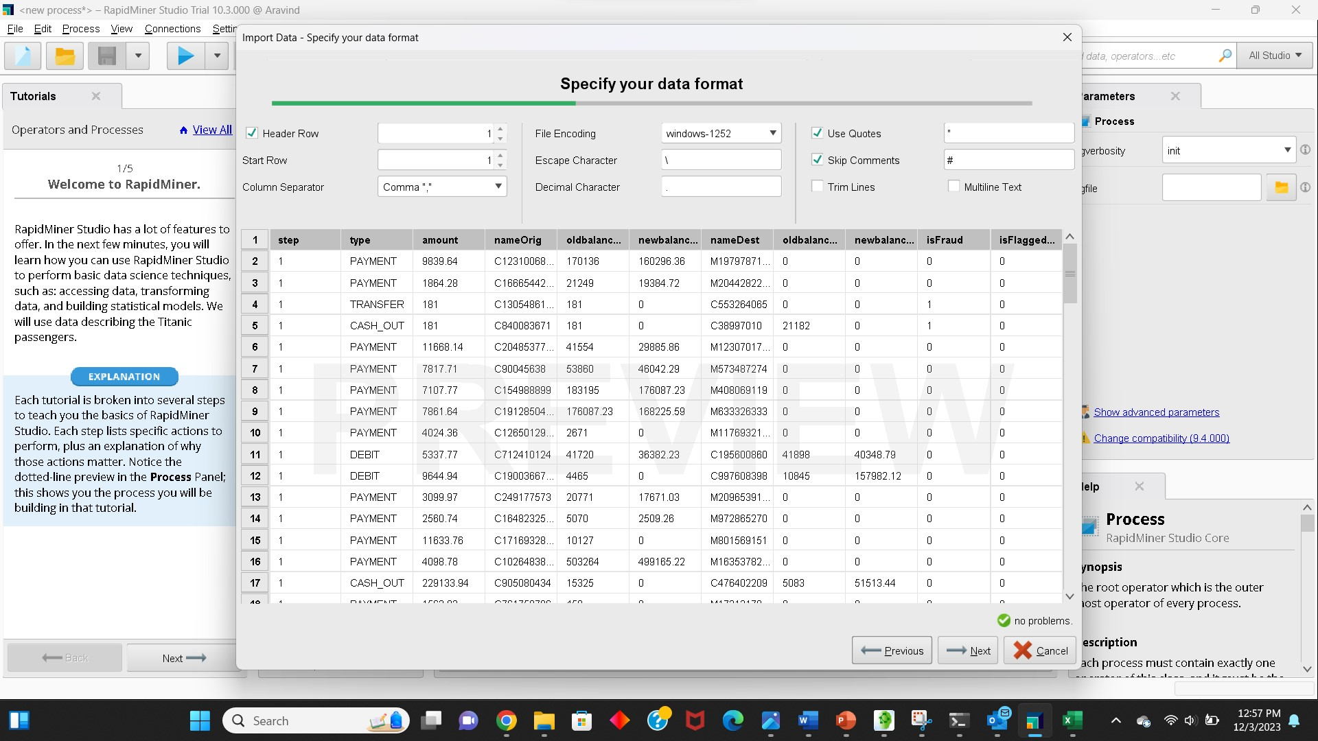

**Data Exploration and Preprocessing**

There might be some missing values in the data set. We cannot see each cell if there is any, missing or not so I have selected check box of replace errors with missing values.

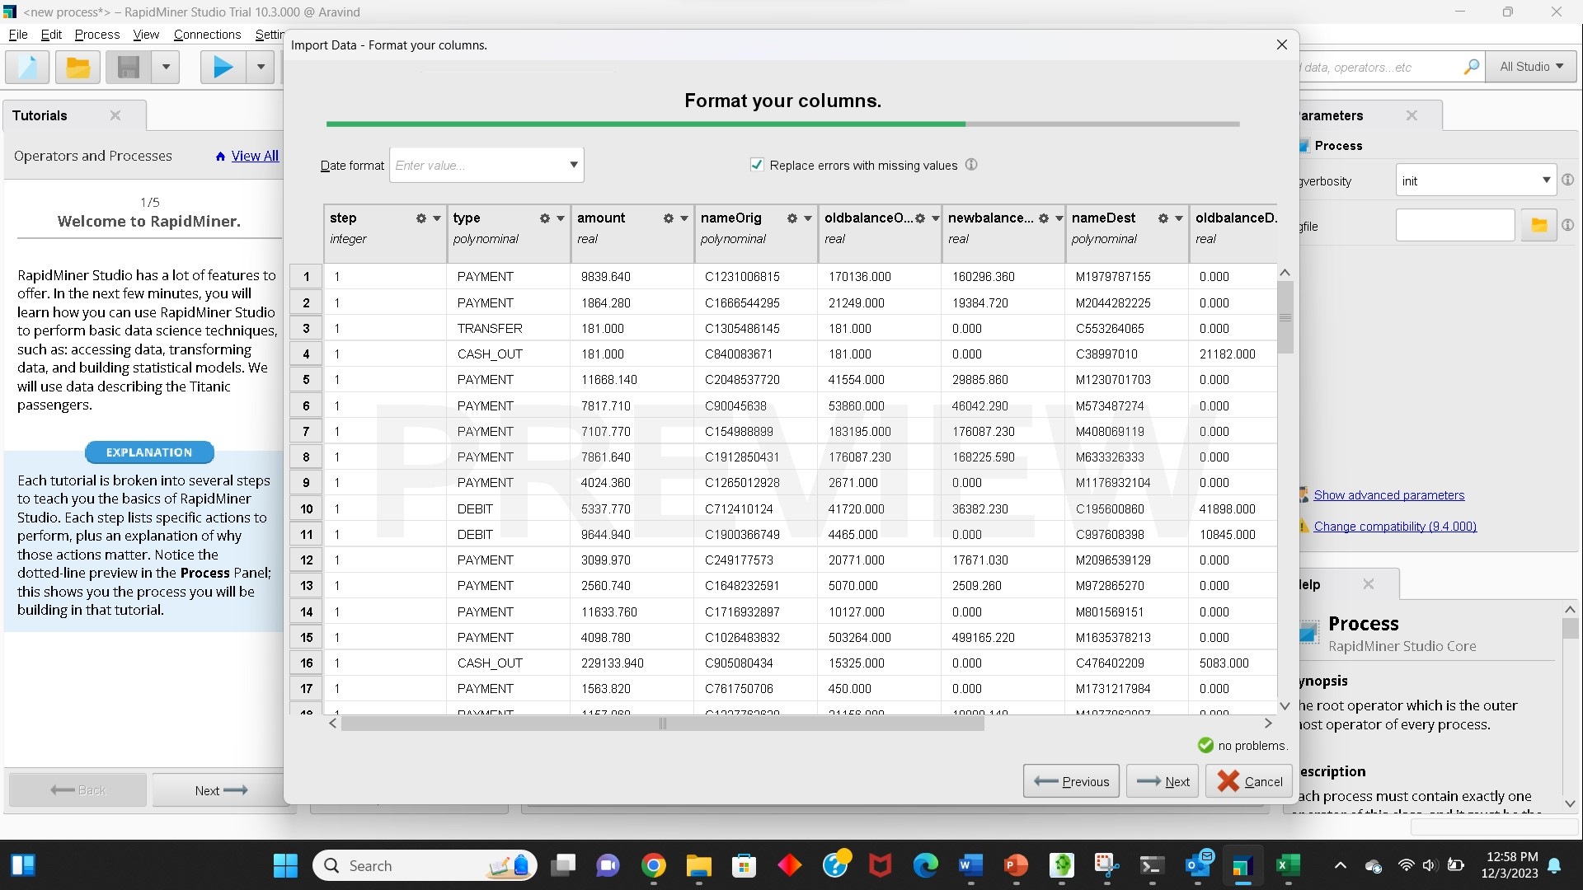

Now we replace those missing values with average.

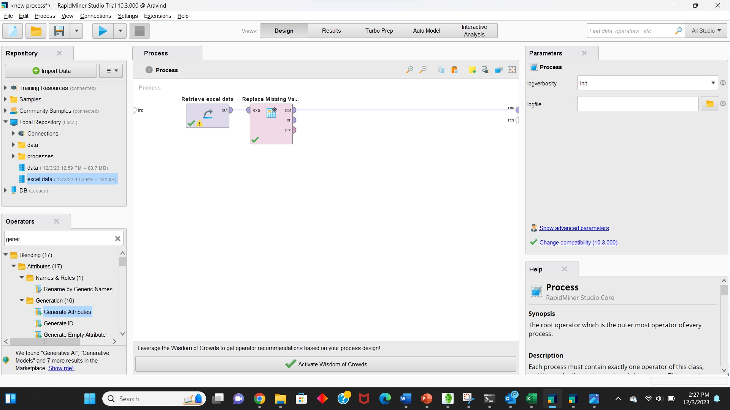

**Data Analysis:**

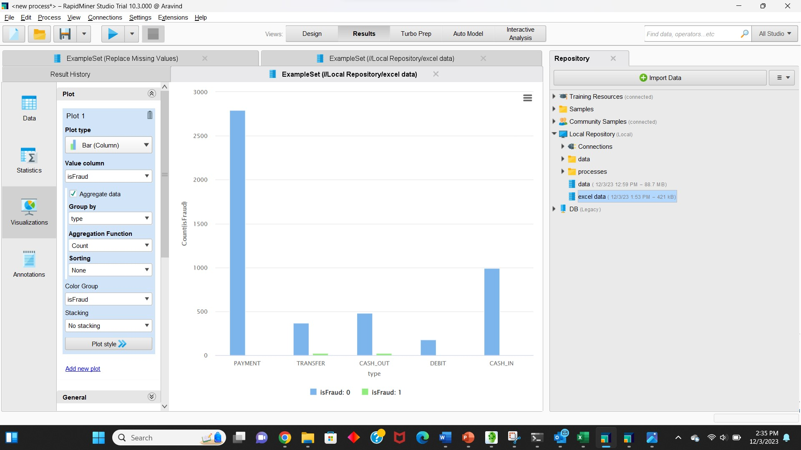

**What transactions are fraudulent?**

Here at the above image, we can clearly see fraud happens at **TRANSFER** and **CASH_OUT**.

The types of transactions that are considered fraudulent in this dataset. Specifically, fraudulent transactions occur in two types:

1. **TRANSFER**: Money is sent to a customer or fraudster.
2. **CASH_OUT**: Money is sent to a merchant who pays the customer or fraudster in cash.

This aligns with the typical modus operandi described for fraudulent transactions in dataset. It's interesting to note that the number of fraudulent TRANSFERs is nearly equal to the number of fraudulent CASH_OUTs, a pattern in the fraudulent activities where funds are first transferred to another account and then cashed out.

**Are anticipated merchant accounts labeled appropriately?**

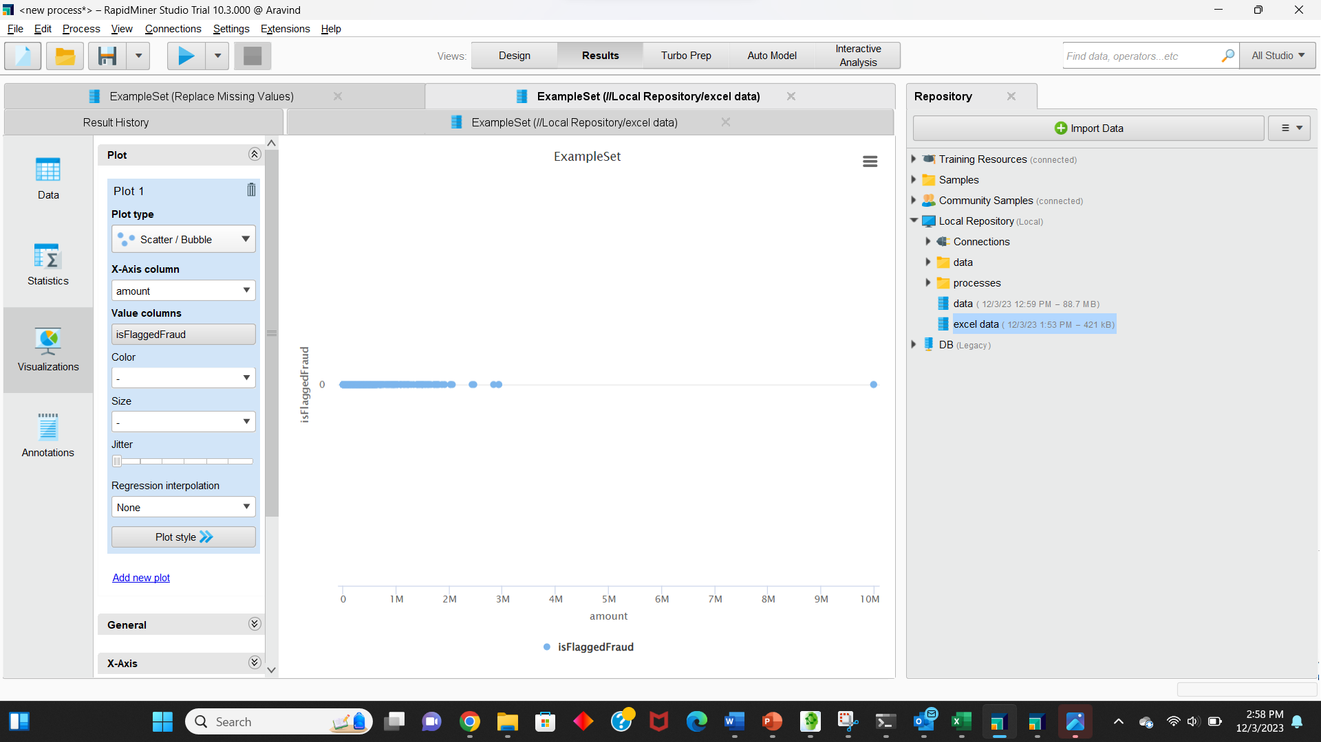

It appears that there is disagreement or ambiguity around the isFlaggedFraud feature's decision. 'TRANSFER' a 'amount' more than 200,000 is allegedly the trigger for activating this capability, according to the information supplied. Nevertheless, the isFlaggedFraud feature is set only 16 items (out of 6 million) in the real data, and it doesn't appear to correspond with any explanatory variable.

There are concerns regarding the precision and consistency of the isFlaggedFraud feature due to this mismatch with the description that was given. The differences in the dataset suggest that the criteria (TRANSFER of an amount more than 200,000) may not always result in the feature being set.

In conclusion, we may understand this feature even if isFraud is always set while isFlaggedFraud is set.

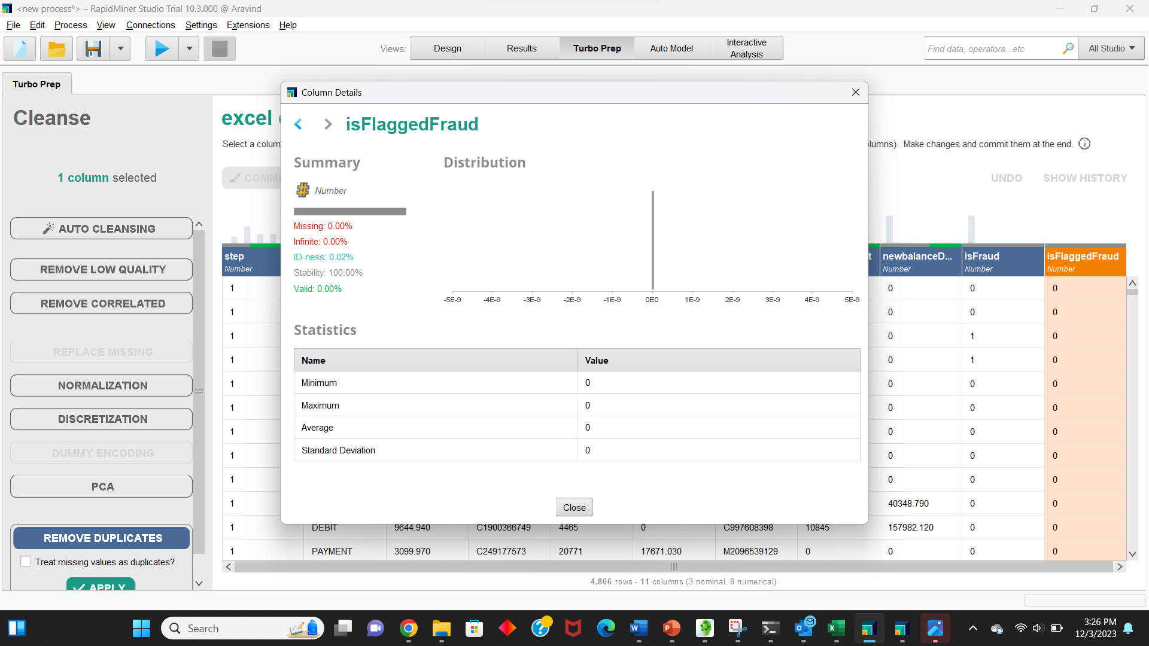

According to [5], CASH_IN entails receiving payment from a merchant (whose name is preceded by 'M'). Nevertheless, as can be seen below, there are no merchants providing CASH_IN transactions to clients in the current data.

It was also said that CASH_OUT entails paying a seller. There aren't any merchants listed among the destination accounts for CASH_OUT transactions, though.

**Are there account labels common to fraudulent TRANSFERs and CASH_OUTs?**

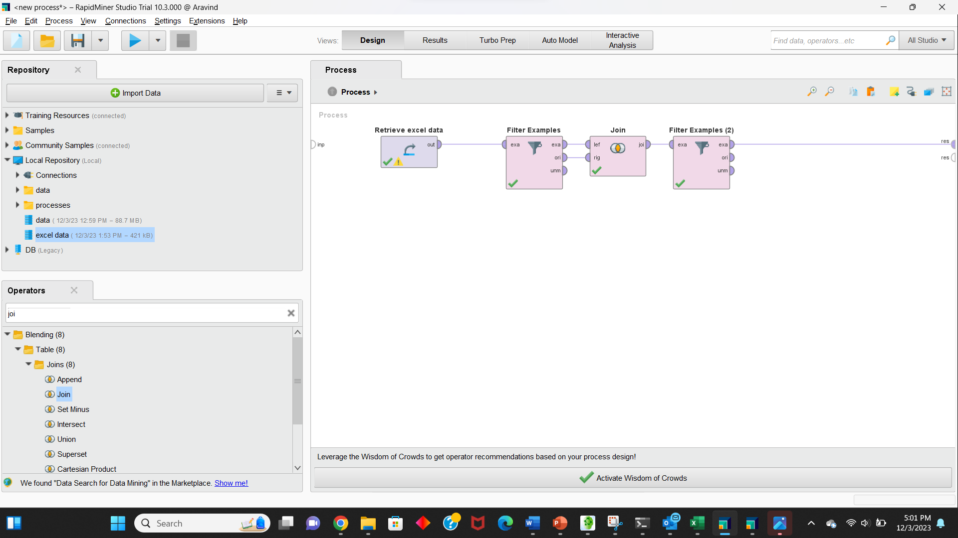

I have selected the filter examples looking for transfers in type column and is a fraud and cash_out in type and is a fraud later using join operator to join to know whether a fraudulent transaction is.

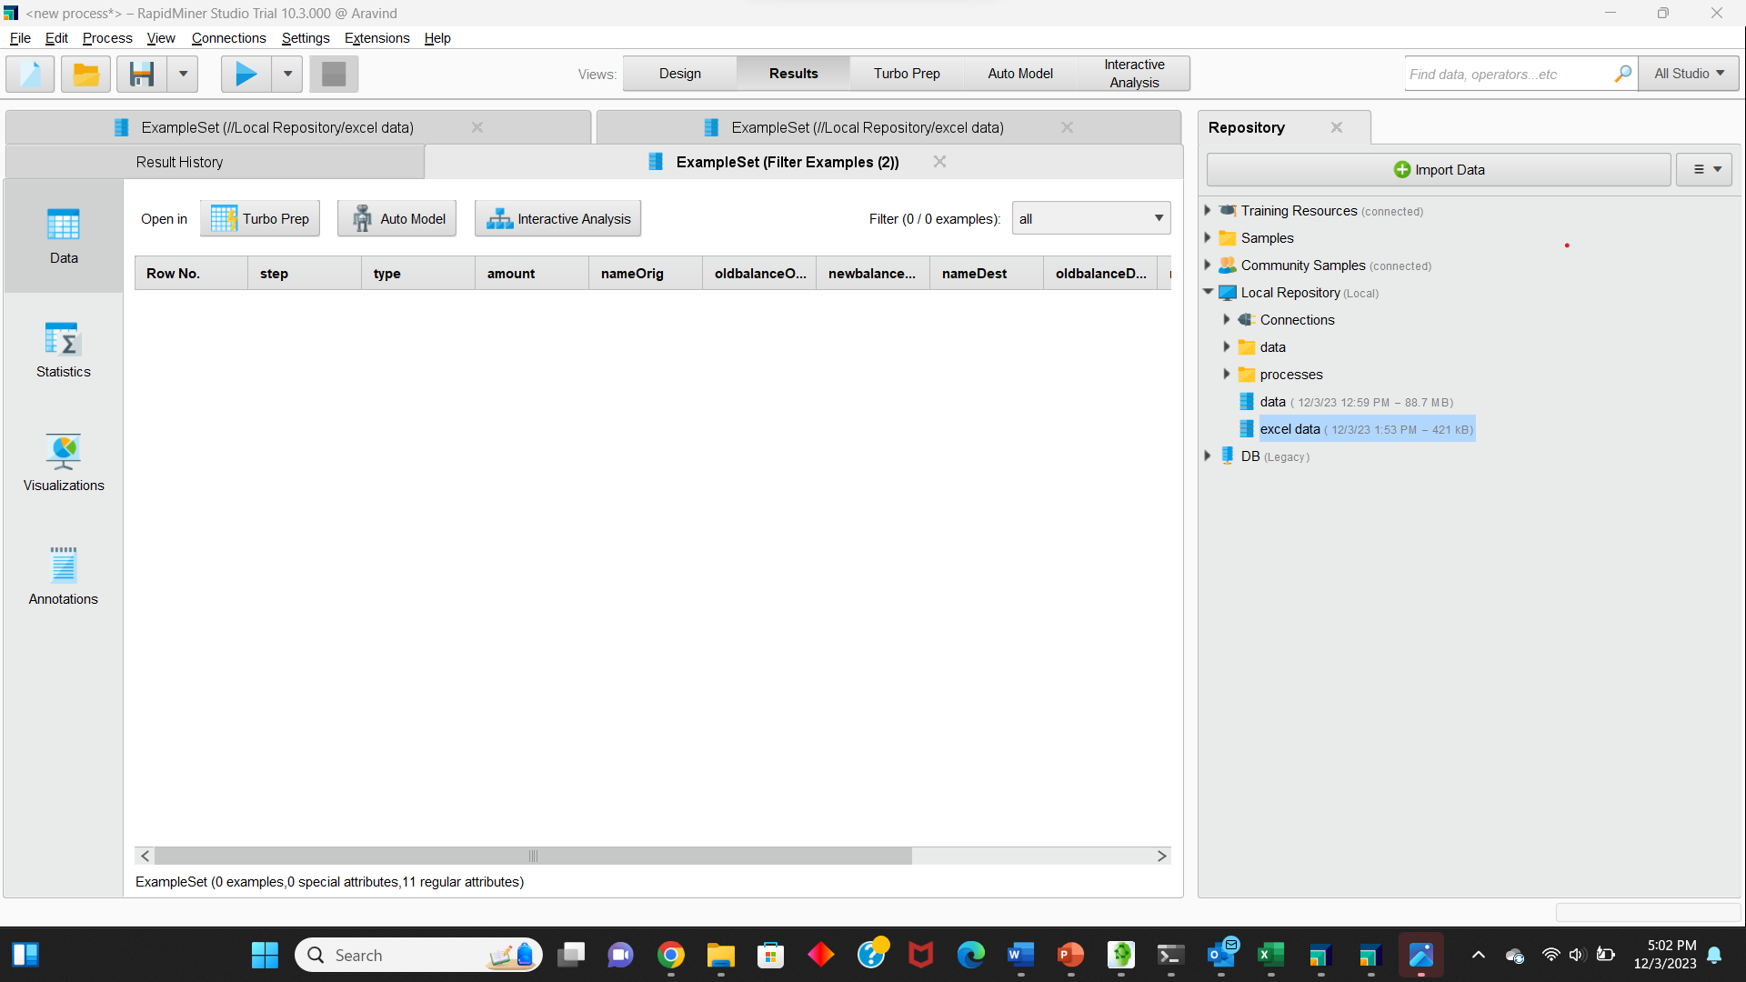

The results came to nothing and have these nameOrig and nameDest are of no use,So I have decided to drop them.

**Binary Encoding of 'type':** I used the "Nominal to Numerical" operator to convert the 'type' column to a numerical format. Assign a unique numerical value to each category. I assigned 1 to 'TRANSFER' and 2 to 'CASH_OUT'.

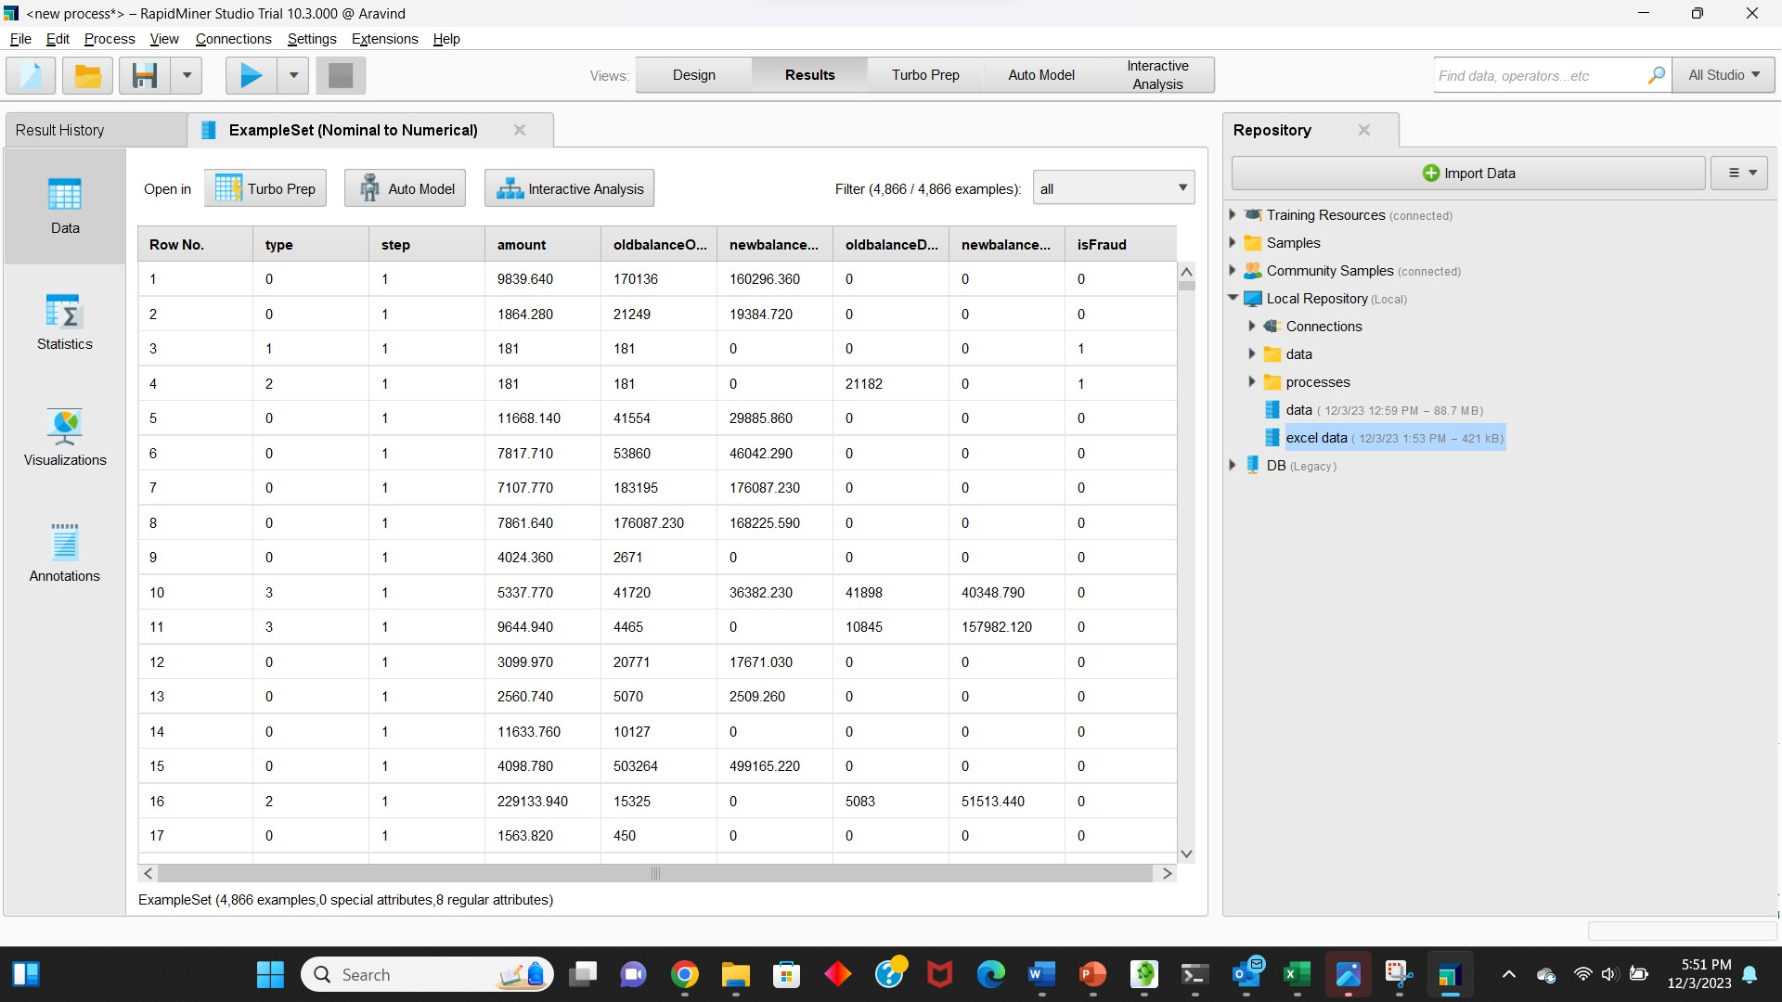

**Filter Transactions:**

* Since you are interested in 'TRANSFER' and 'CASH_OUT' transactions, use the "Filter Examples" operator to keep only these types of transactions.
* Connect the output port to the next step.

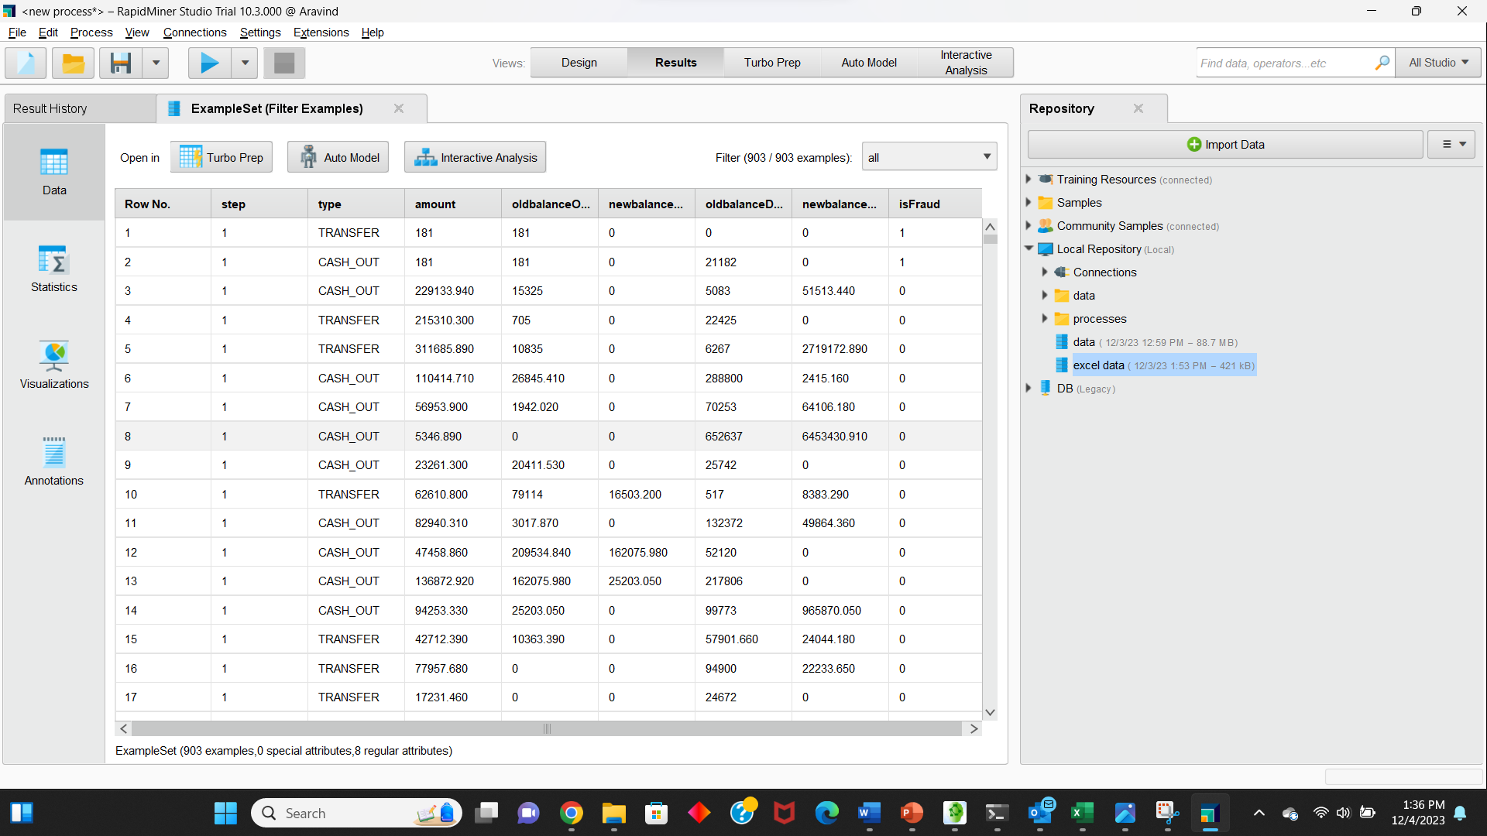

**Handling zero Balances**

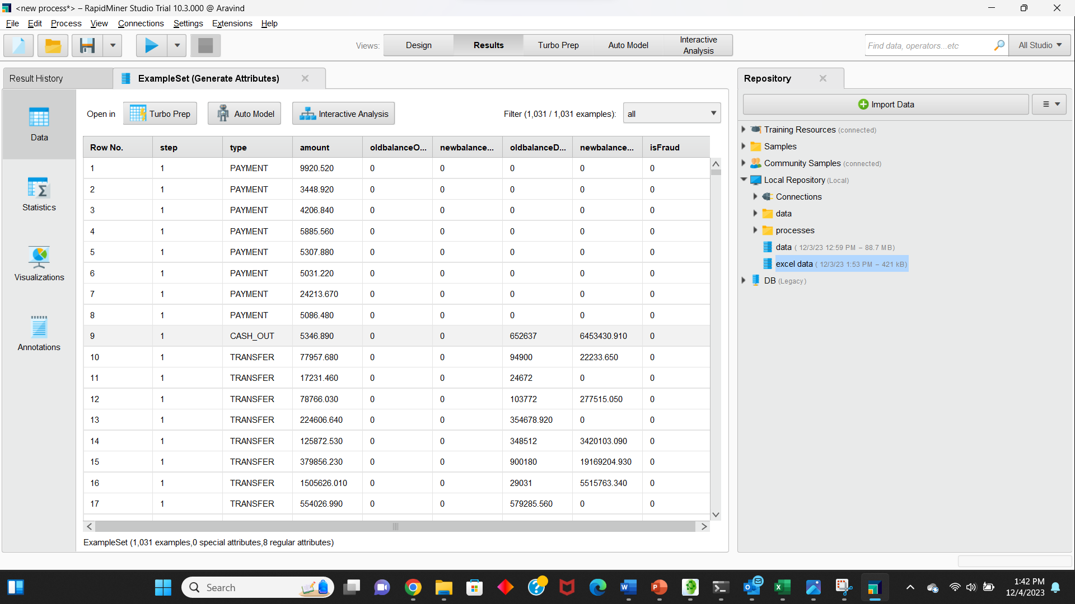

Inside the "Generate Attributes" operator, create a new attribute, let's call it "adjustedOldBalanceDest."

**Code : if**((oldbalanceDest **==** 0) **&&** (newbalanceDest **==** 0) **&&** (amount **!=** 0), **-**1, oldbalanceDest)

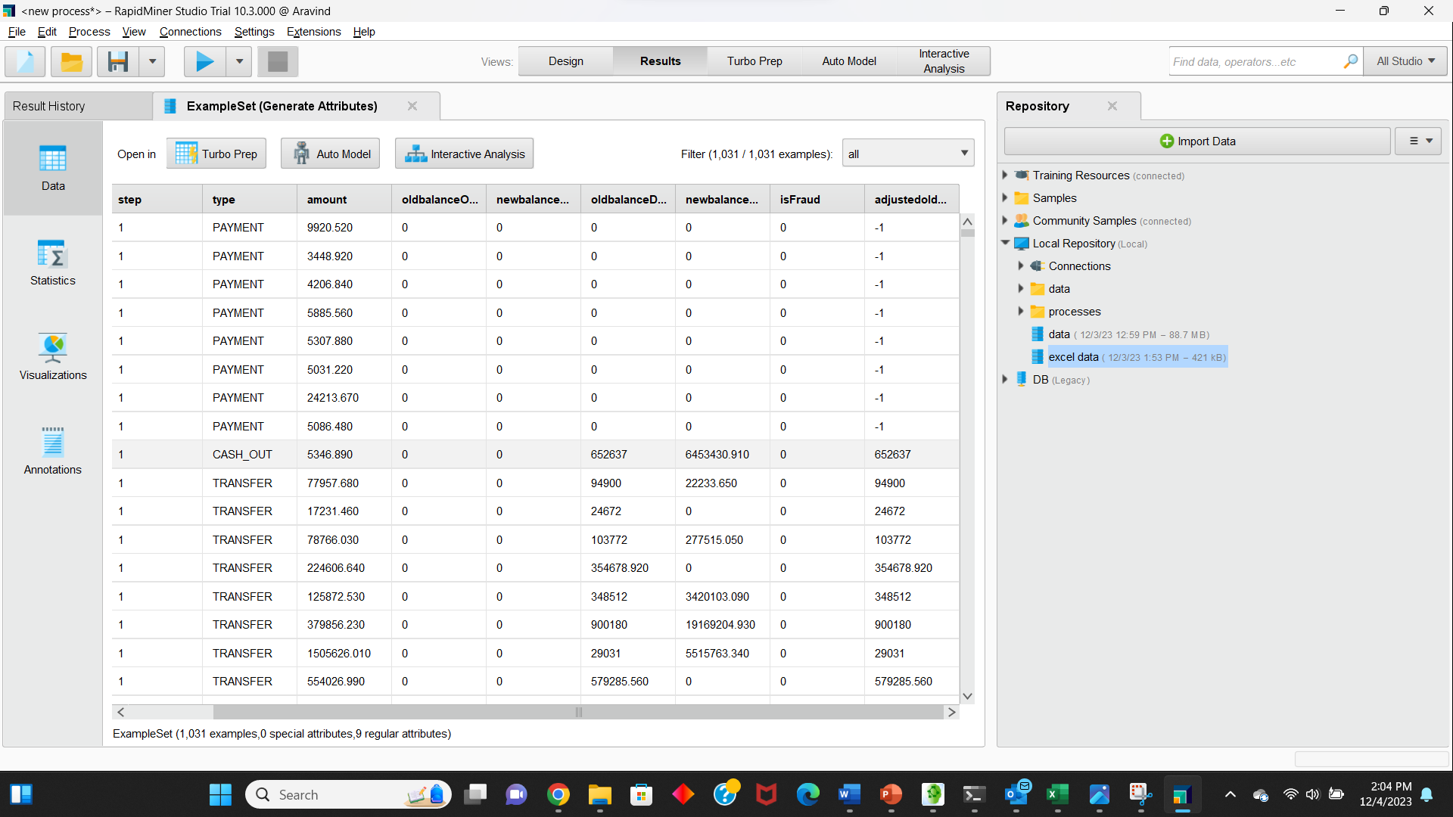

**Data Visualization:**

Attempting to visually observe the distinctions between fraudulent and legitimate transactions is the best approach to verify if the data has sufficient information for a machine learning system to provide robust predictions. Inspired by this idea, I've plotted these differences in other ways below.

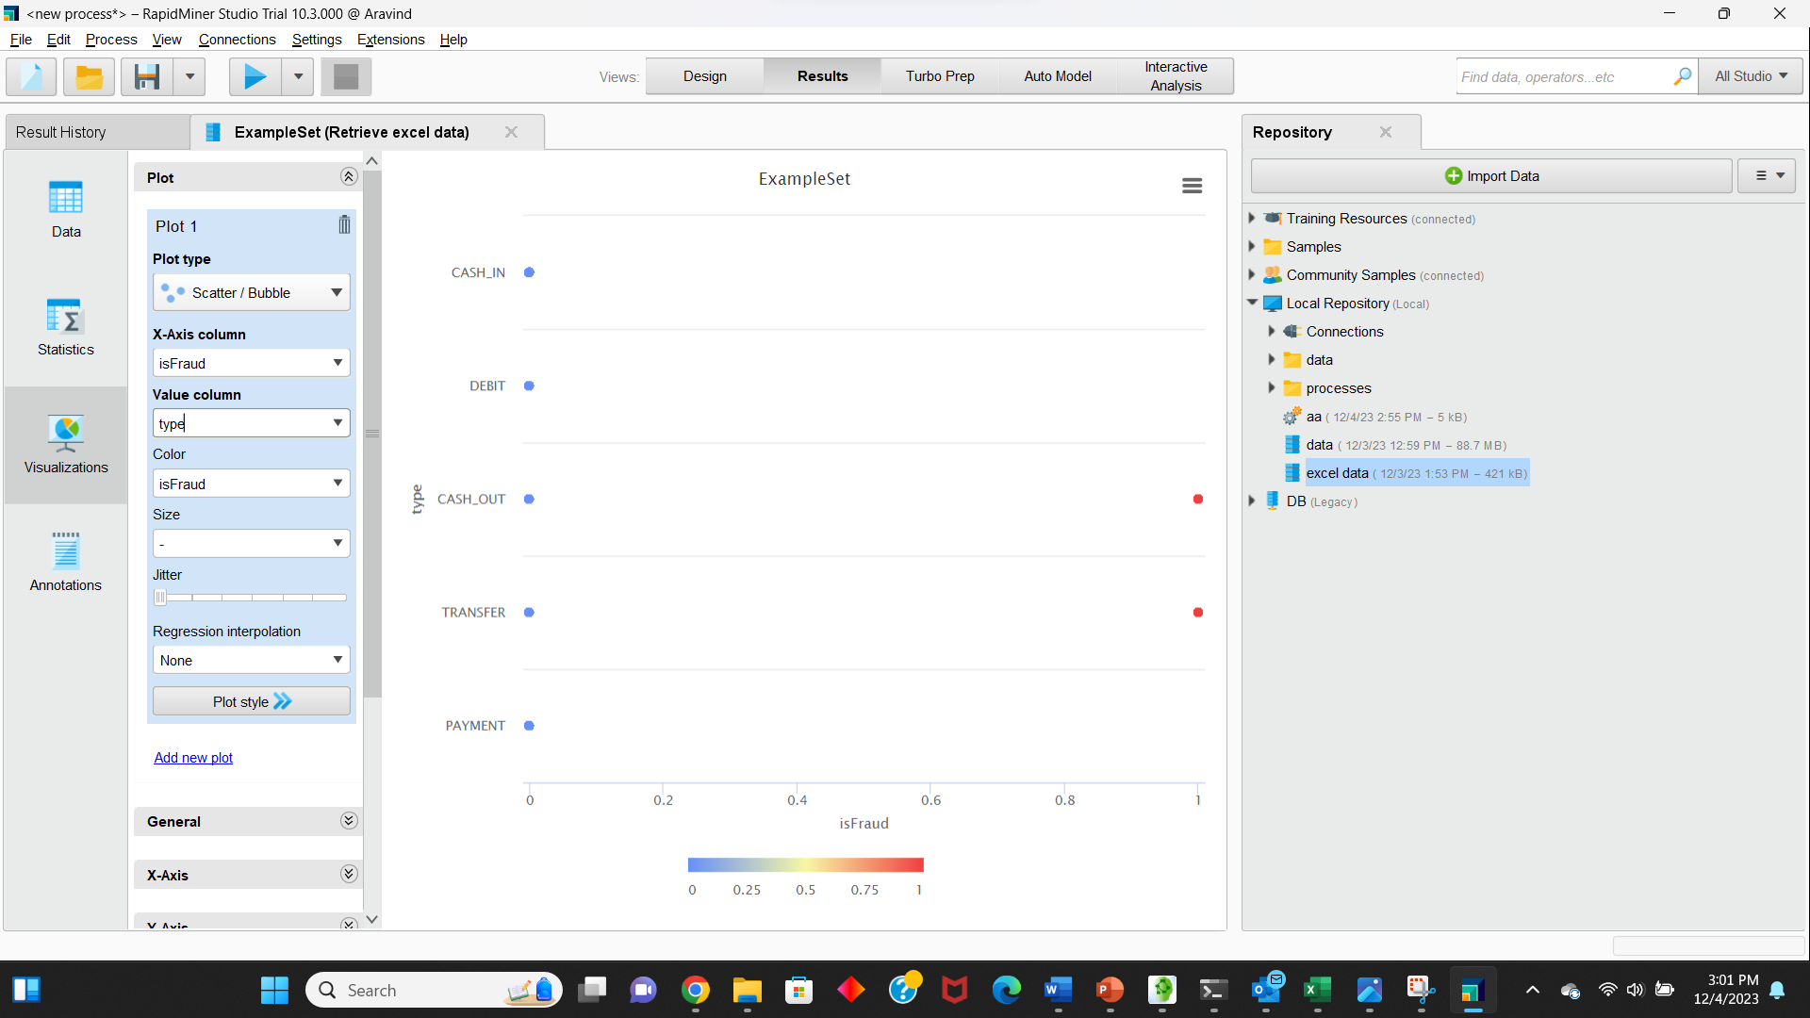

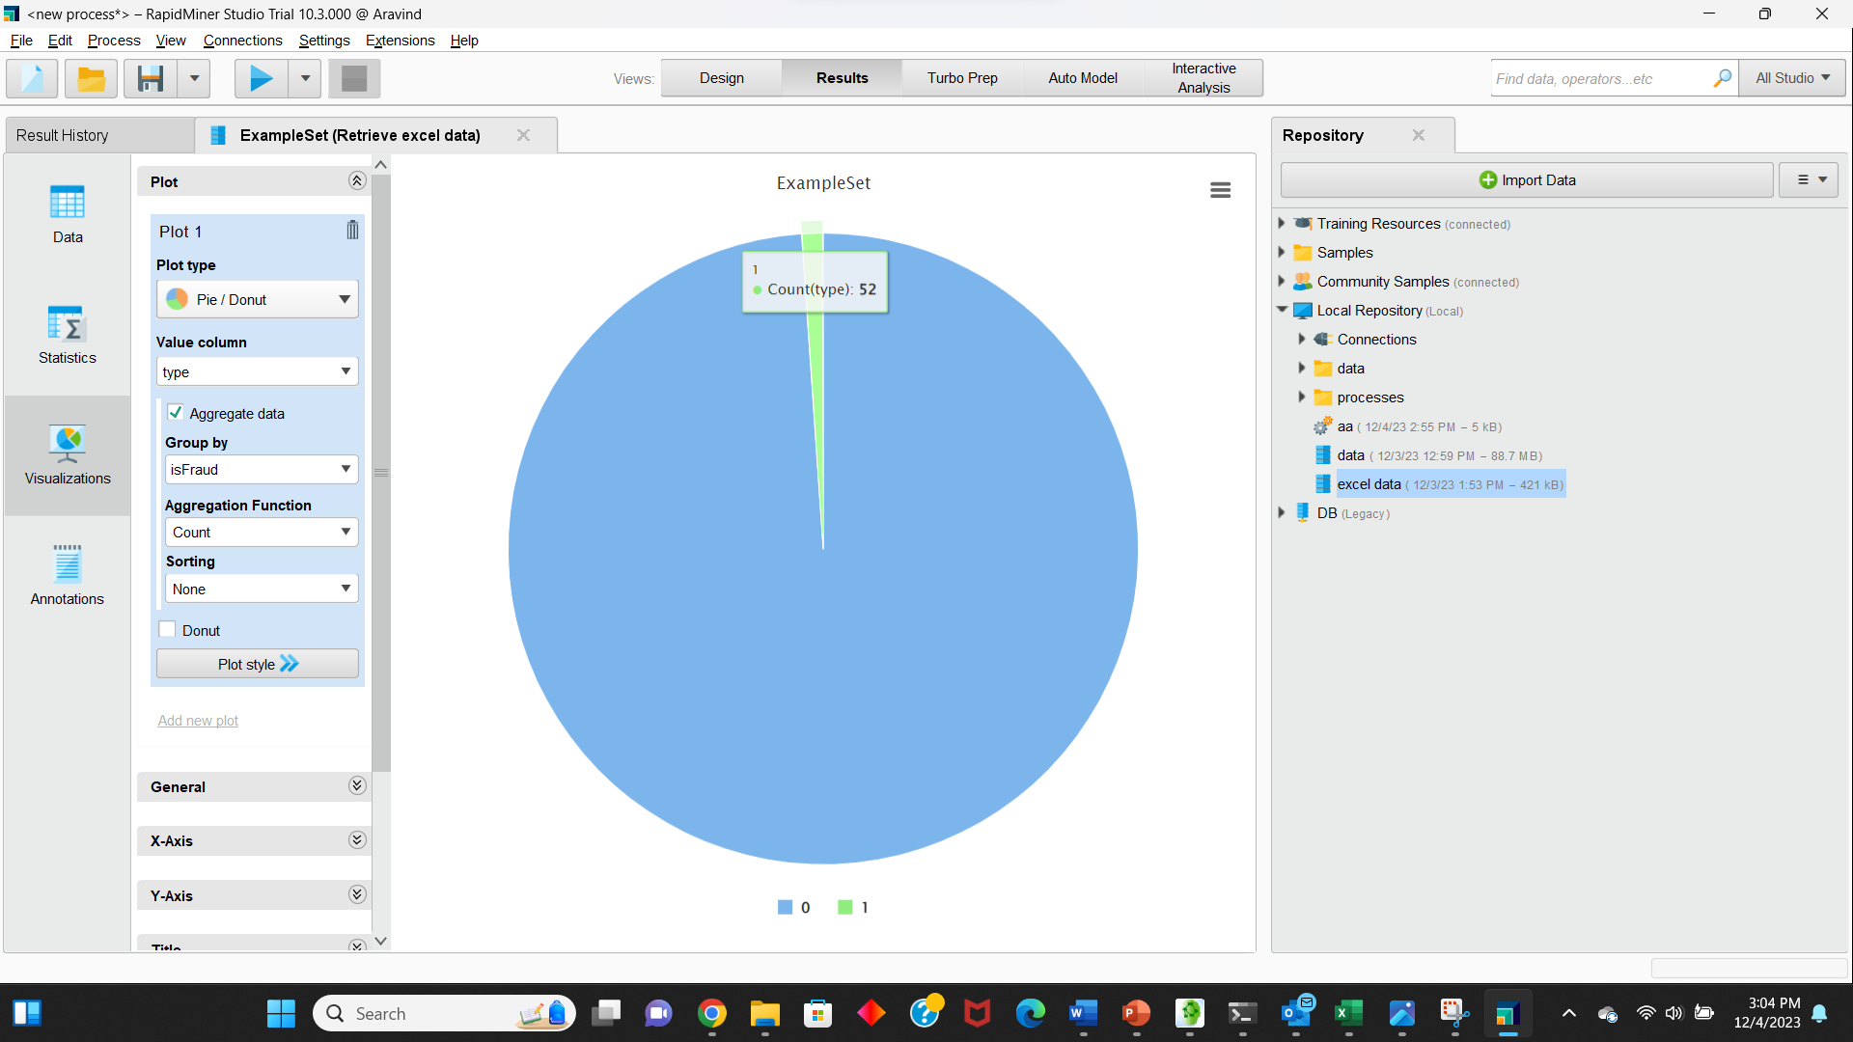

**Dispersion over time**

The plot below shows how the fraudulent and genuine transactions yield different fingerprints when their dispersion is viewed over time. Fradulent transactions are more homogenously distributed over time compared to genuine transactions. Also apparent is that CASH-OUTs outnumber TRANSFERs in genuine transactions, in contrast to a balanced distribution between them in fraudulent transactions. Note that the the width of each 'fingerprint' is set by the 'jitter' parameter in the plotStrip function above which attempts to separate out and plot transactions occuring at the same time with different abscissae.

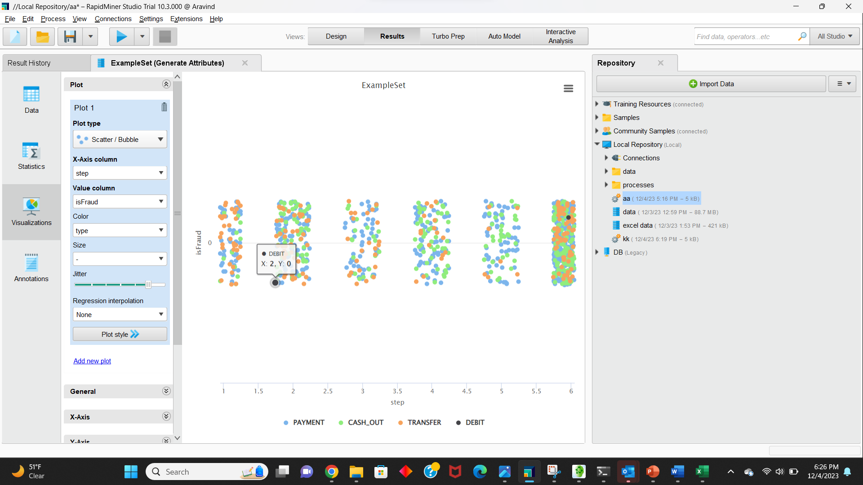

The plot below shows that although the presence of fraud in a transaction can be discerned by the original *amount* feature, the new *errorBalanceDest* feature is more effective at making a distinction.

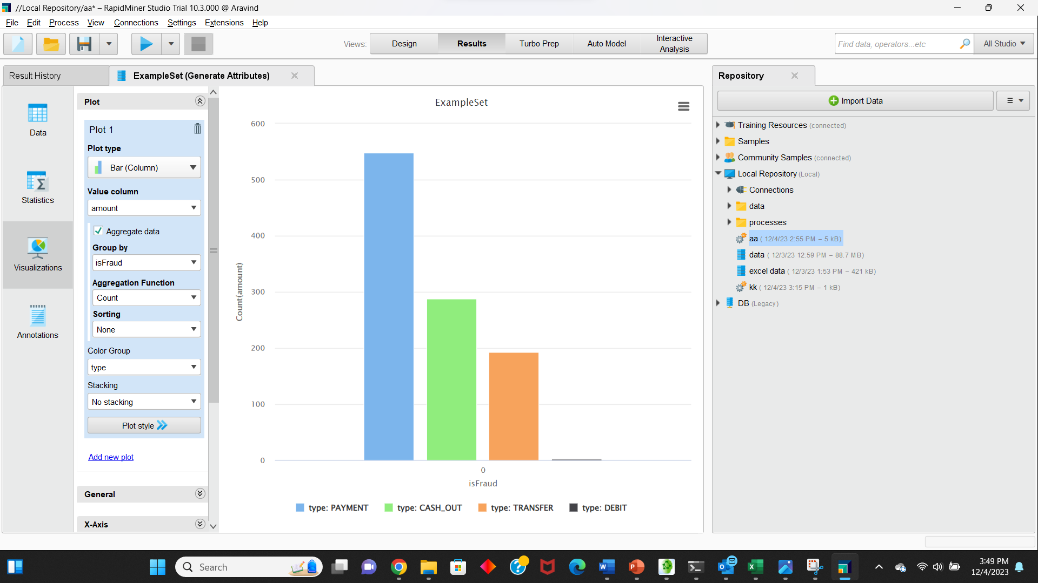

Dispersion over error in balance in destination accounts

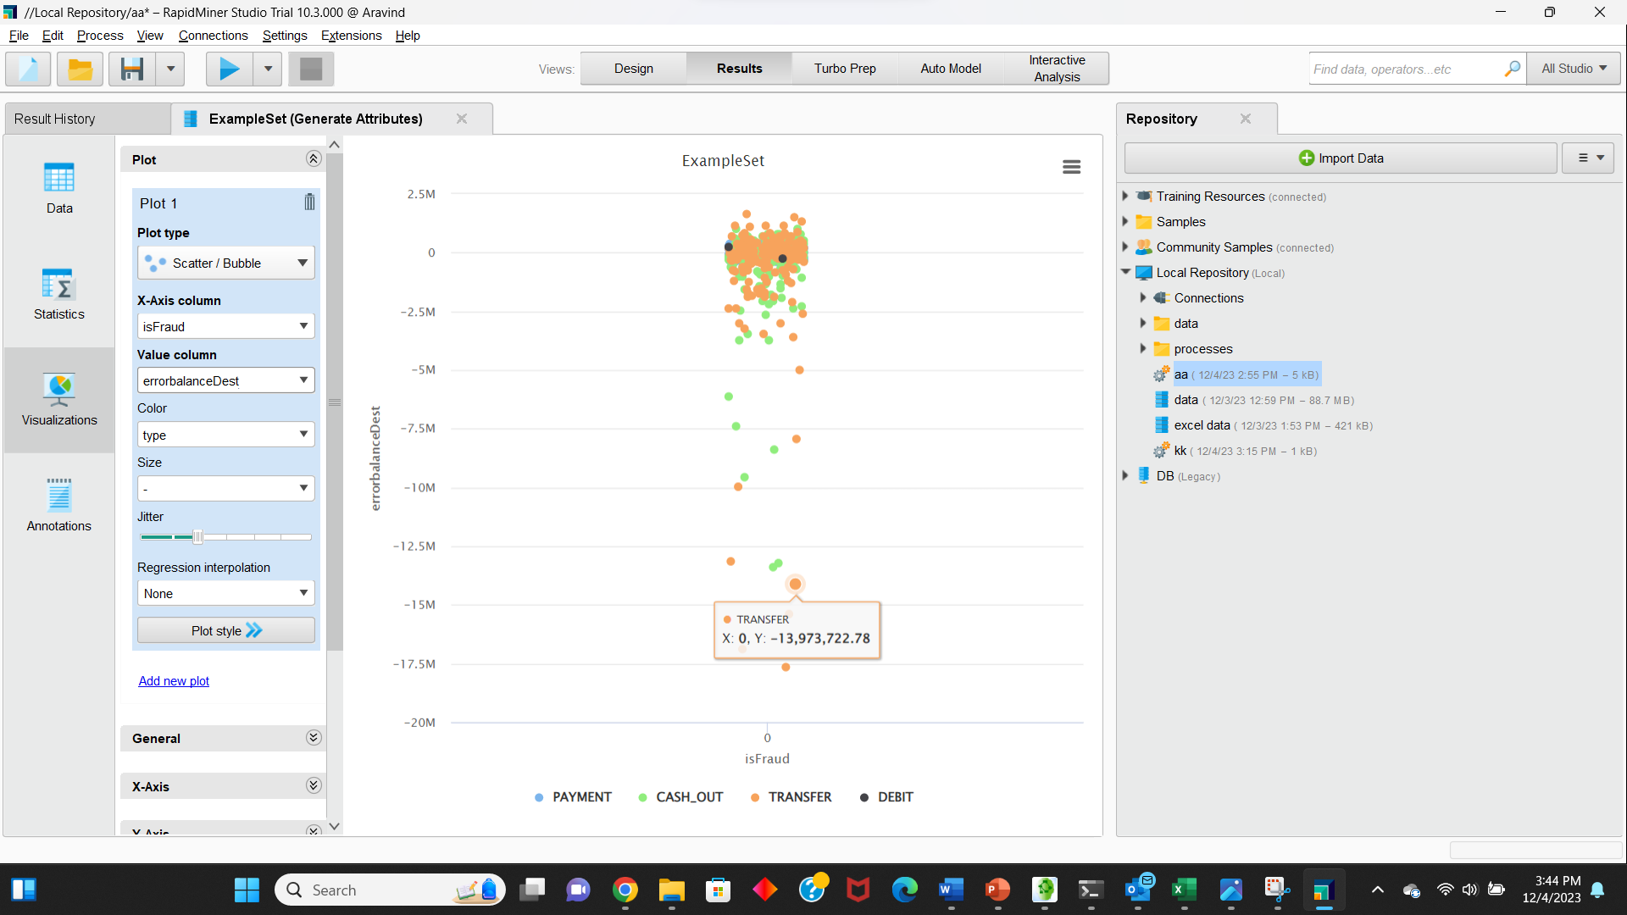

**Separating out genuine from fraudulent transactions:**

The 3D plot below distinguishes best between fraud and non-fraud data by using both engineered error-based features. Clearly, the original *step* feature is ineffective in separating out fraud.

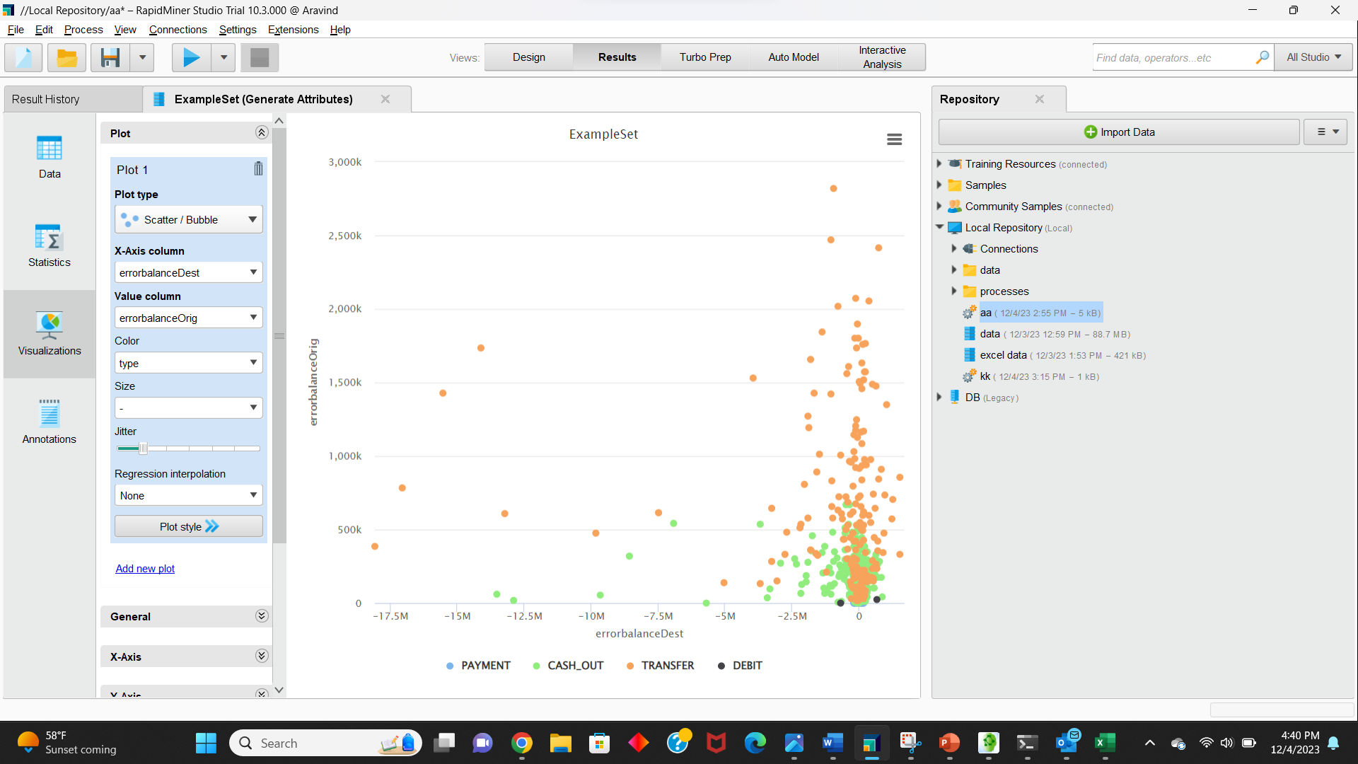

**What are the important features of the ML model?**

The new feature *errorBalanceOrig* that we created is the most relevant feature for the model. The features are ordered based on the number of samples affected by splits on those features.

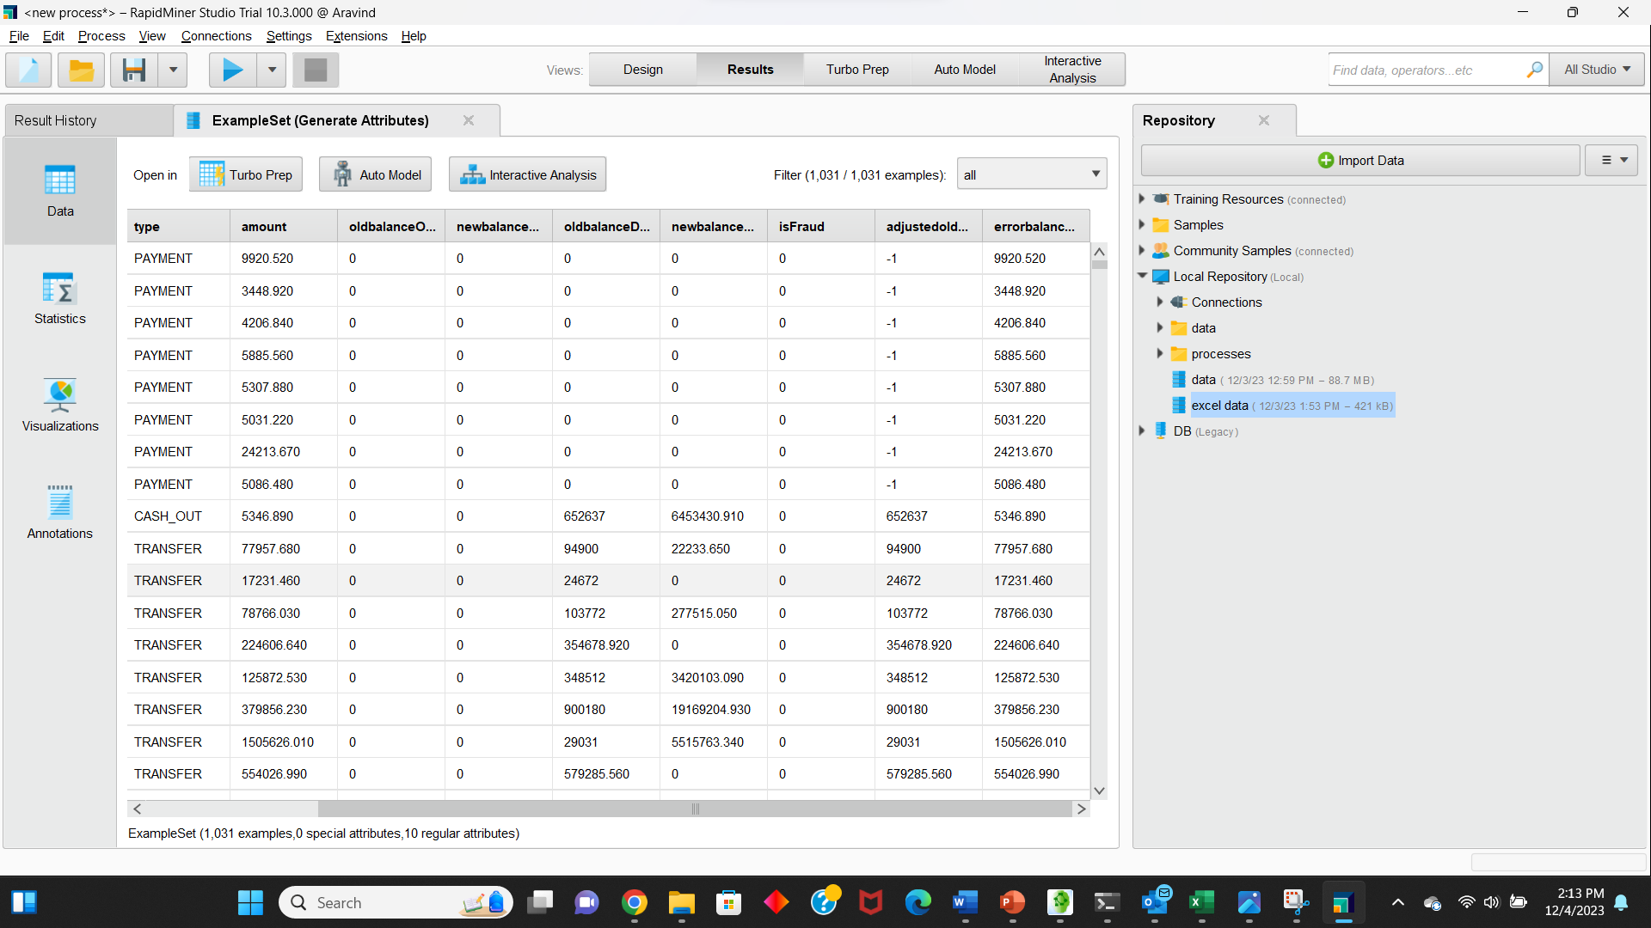

For this we must set a role for isFraud as a label and split data into 0.3 and 0.7. and connect to them to decision tree and apply model, then we will get the prediction and the confidence.

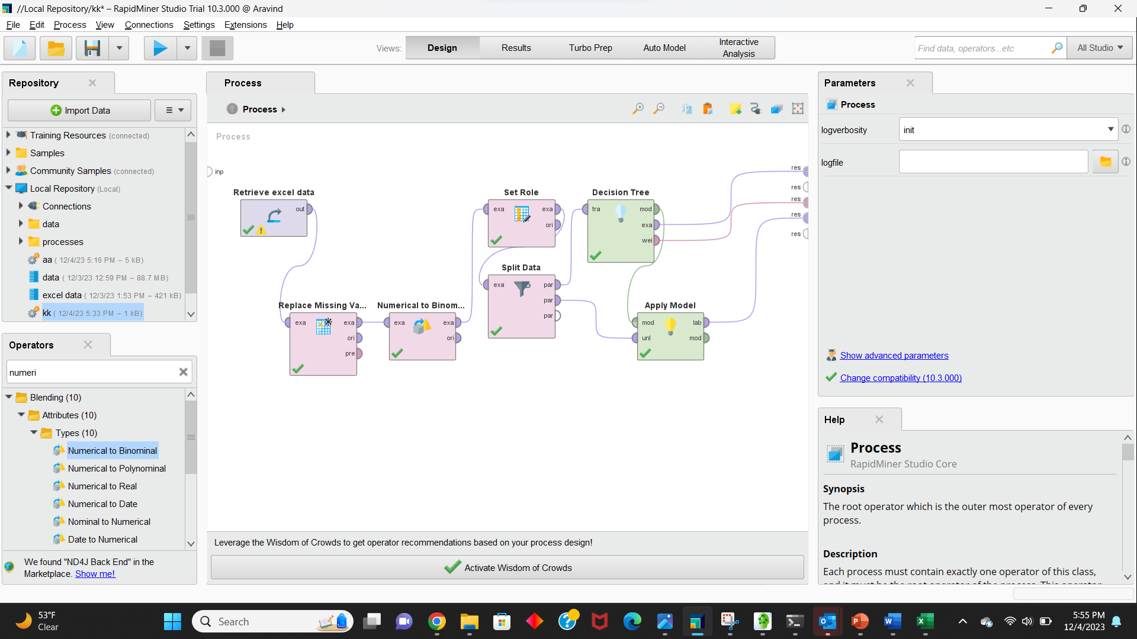

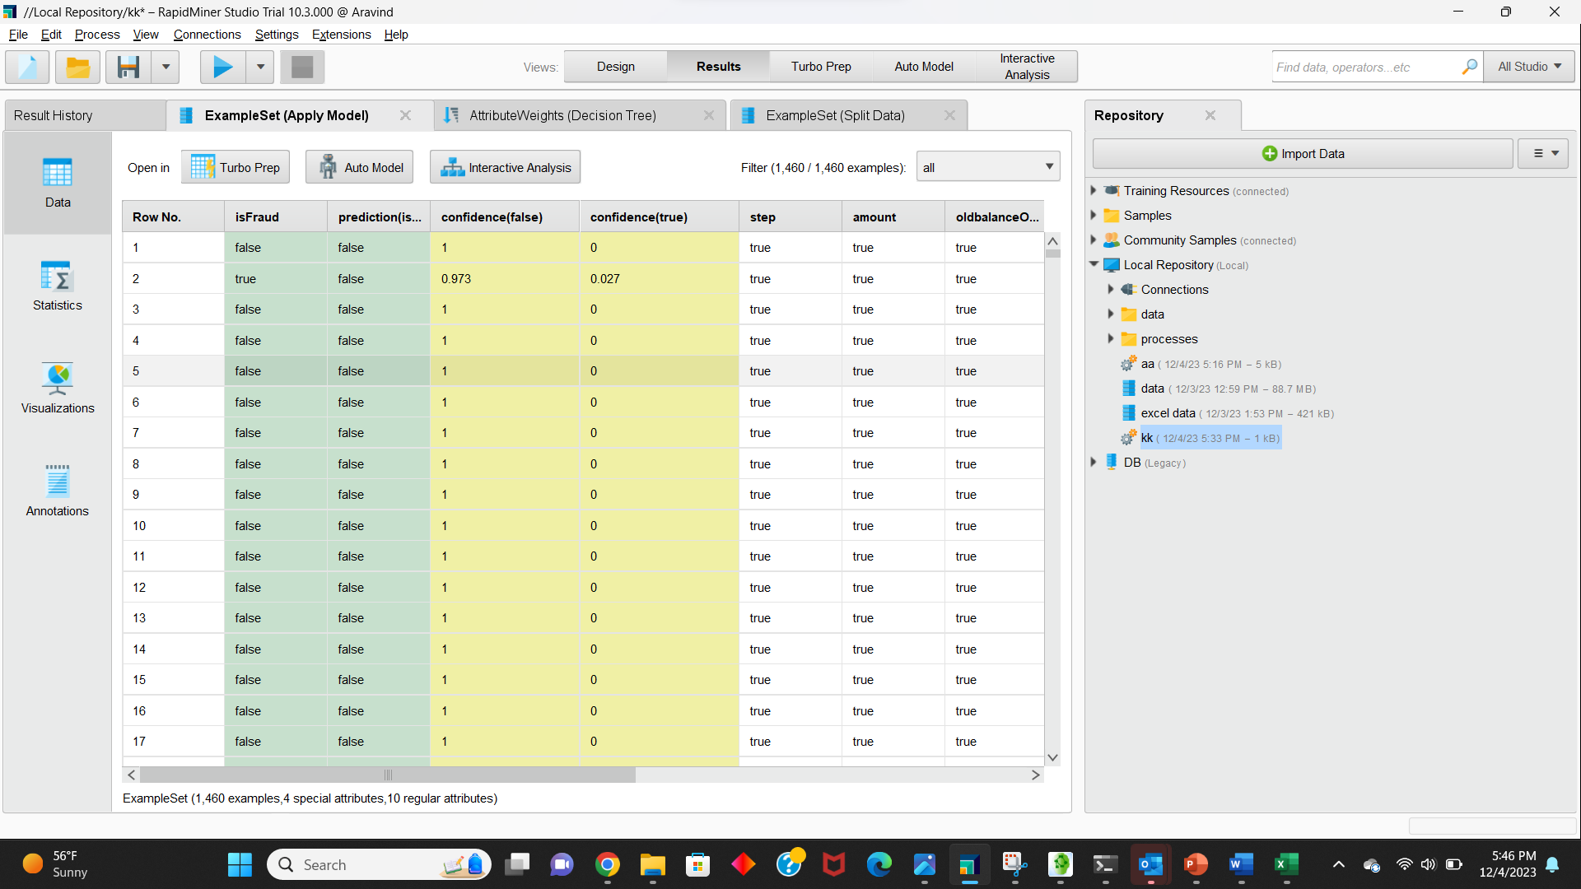

To get the accuracy we will add a performance operator and the accuracy of the model is 99.93.

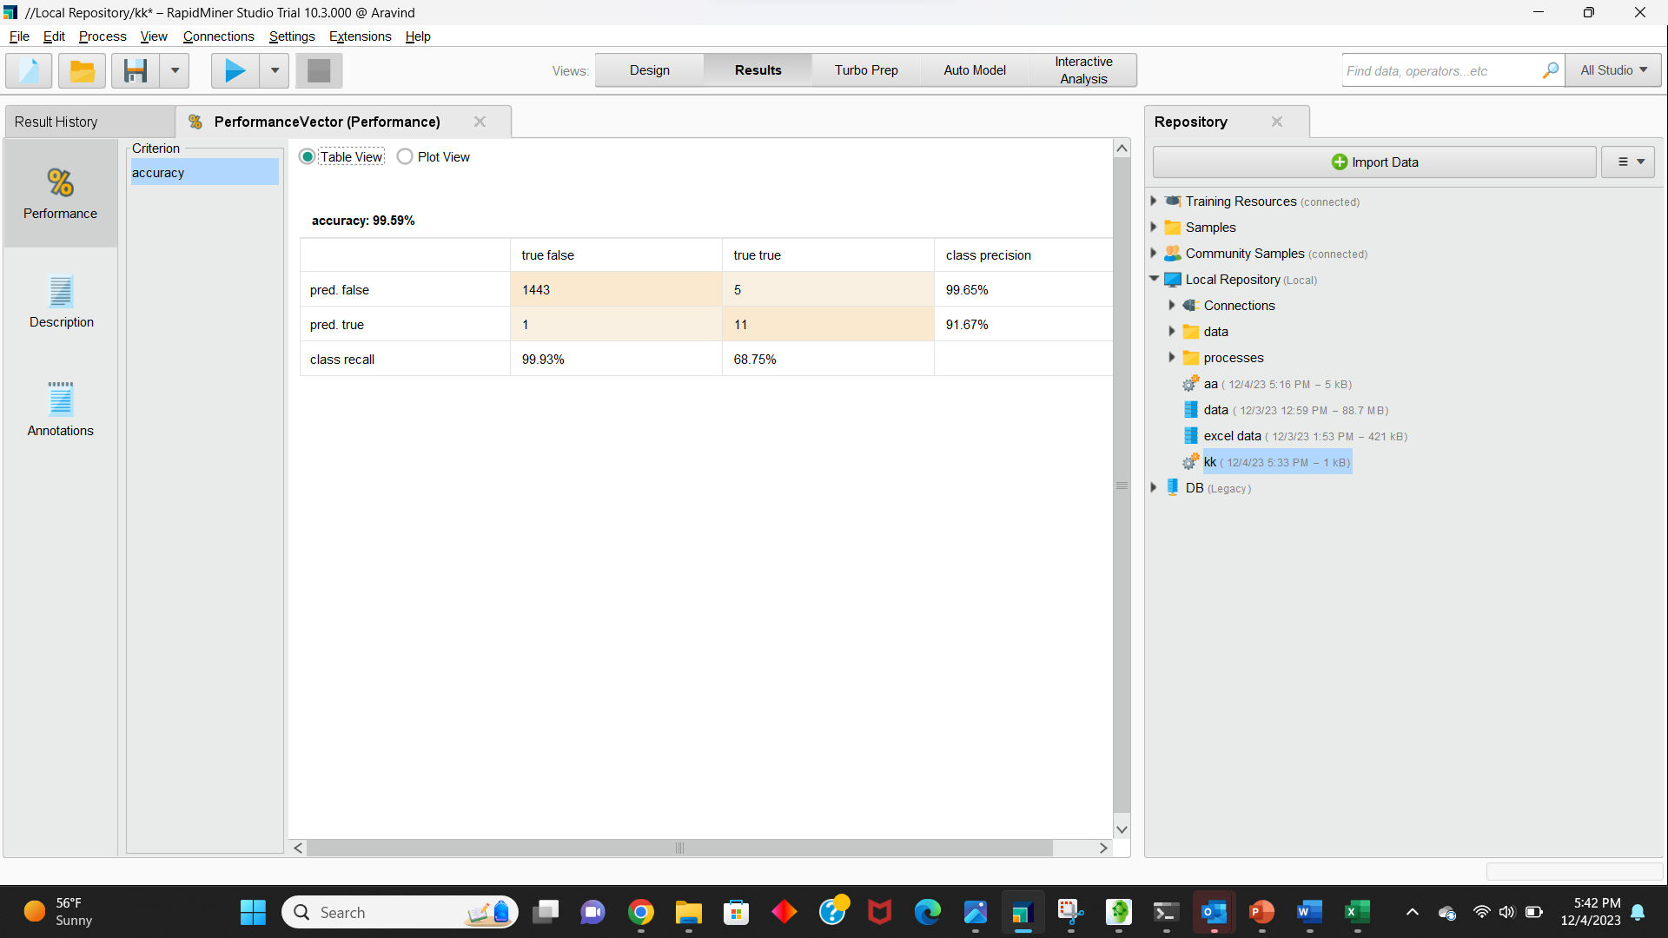

Decision Tree:

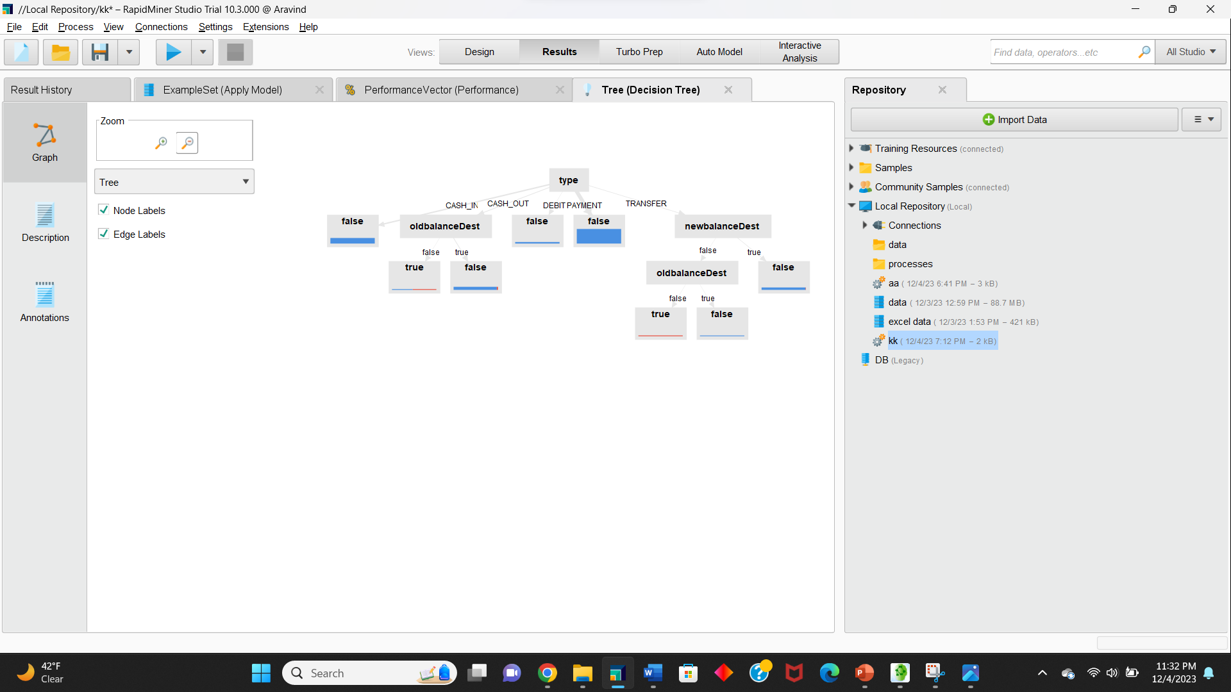

In this conclusion provides a clear summary of the key steps and findings in analysis:

1. Interrogated the data thoroughly to understand feature importance.
2. Engaged in feature engineering based on insights from the initial data exploration.
3. Used visualizations to confirm the discriminative power of the new features.
4. Addressed the challenge of imbalanced data by selecting an appropriate metric and choosing an ensemble of decision trees, which is effective for imbalanced classes.

This approach indeed seems versatile and applicable to a broader range of similar problems involving imbalanced datasets. It reflects a systematic and thoughtful process in tackling the challenges posed by the data.